

**HTML -CSS**

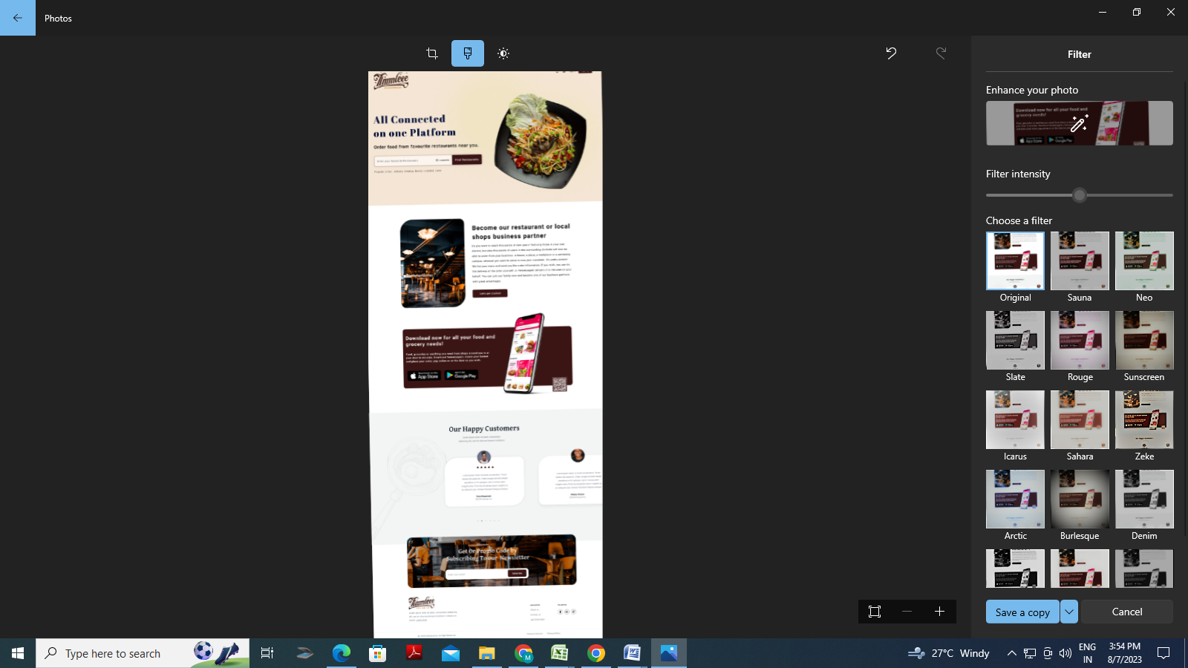**Trainer: Mr.Sunil Jaitly Date:  
  
1. Convert this Mock-up from HTML to CSS.**